Homepage: I would like “Sandpoint’s Original Hot Yoga Studio” the same font but larger and “come as you are…” the same font as Sandpoint’s original hot yoga studio smaller. And all page headings the same font as “Sandpoint’s Original Hot Yoga Studio”
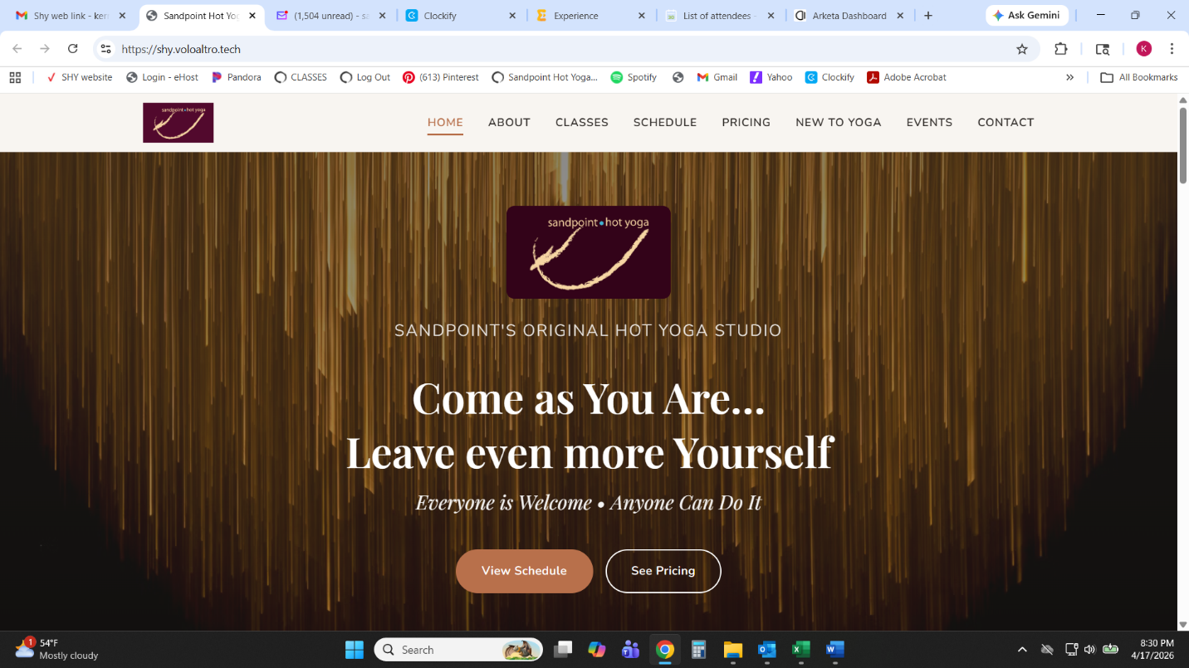

All pages: Delete the small logo on the top right of the header and add the Sandpoint Hot Yoga logo to the top of all pages like on the homepage

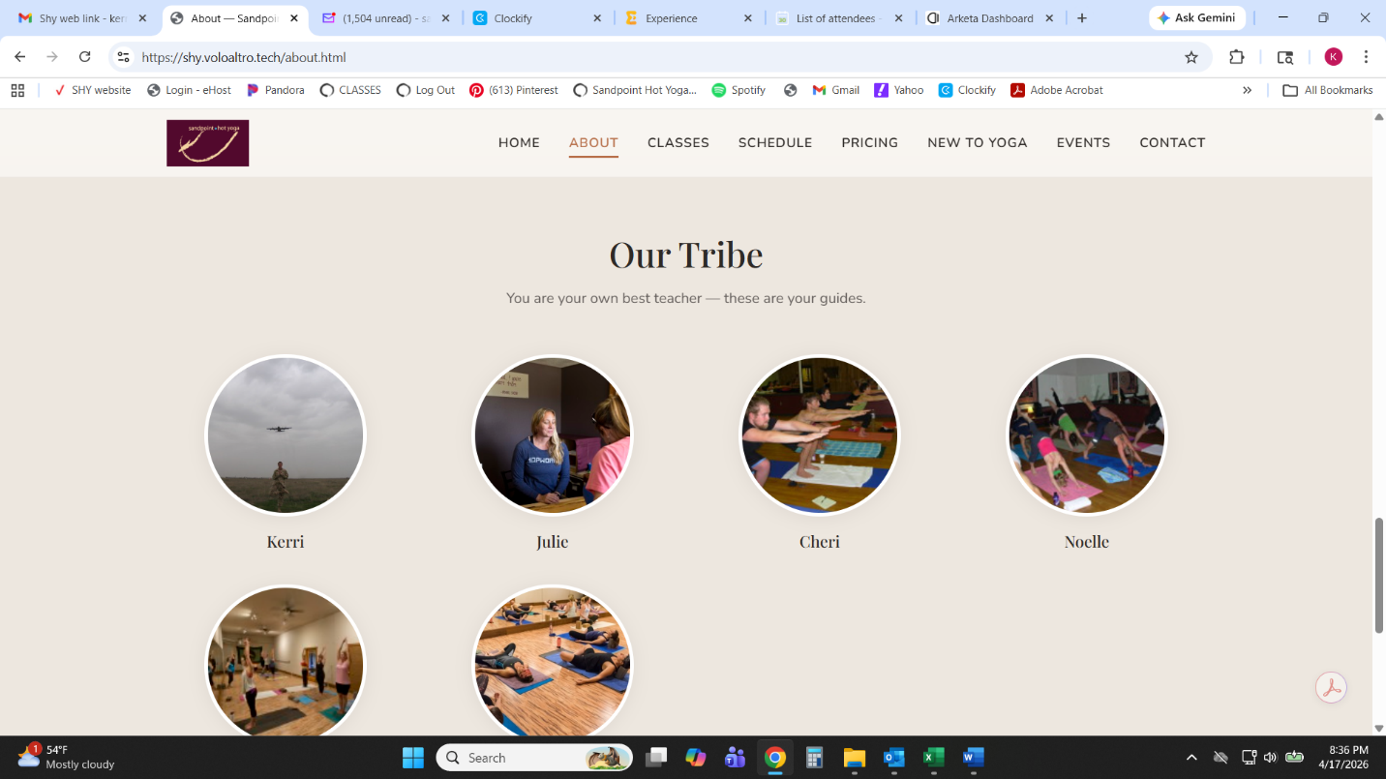
About page: under the “Our Tribe” section, the pictures are wrong, keep the profile pictures the same as the old site at www.sandpointhotyoga.com and make them clickable with the instructor bios

Class Descriptions page: delete fusion and replace with “Pilates Fusion” with the description “Hot pilates based format that may combine elements of mat pilates, yoga, cardio, and the use of props and weights. As with other pilates based classes, the focus is on slow controlled movements....all while getting your heart pumping and staying easy on the joints.”
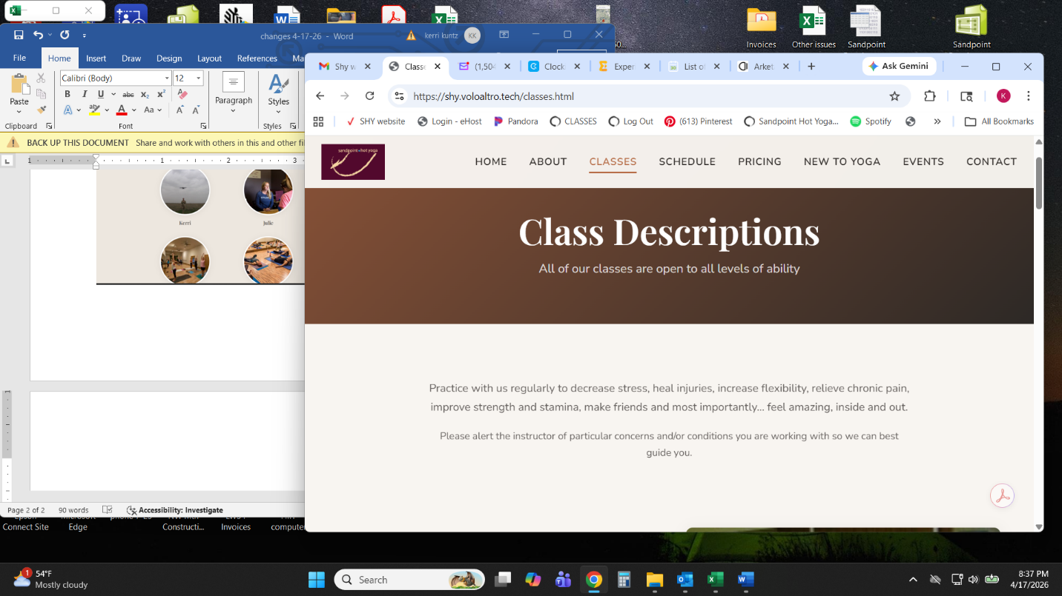
Delete yoga conditioning and replace with “Barre” with the description “Low-impact strengthening movements that combines elements of pilates & yoga. An efficient workout using a bar for support to strengthen core, smaller supportive muscle groups, and improve posture”

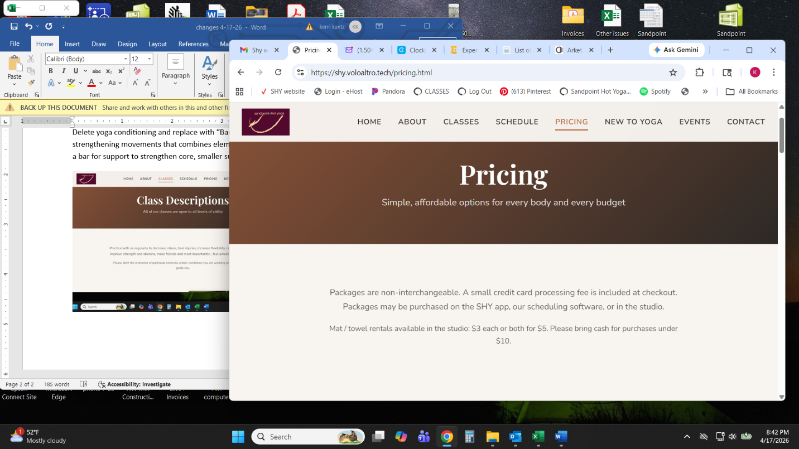
On the Pricing page: delete the text “a small credit card processing fee is included at checkout”

On the “New to Yoga” page: delete the photo and replace with something else that I will provide later
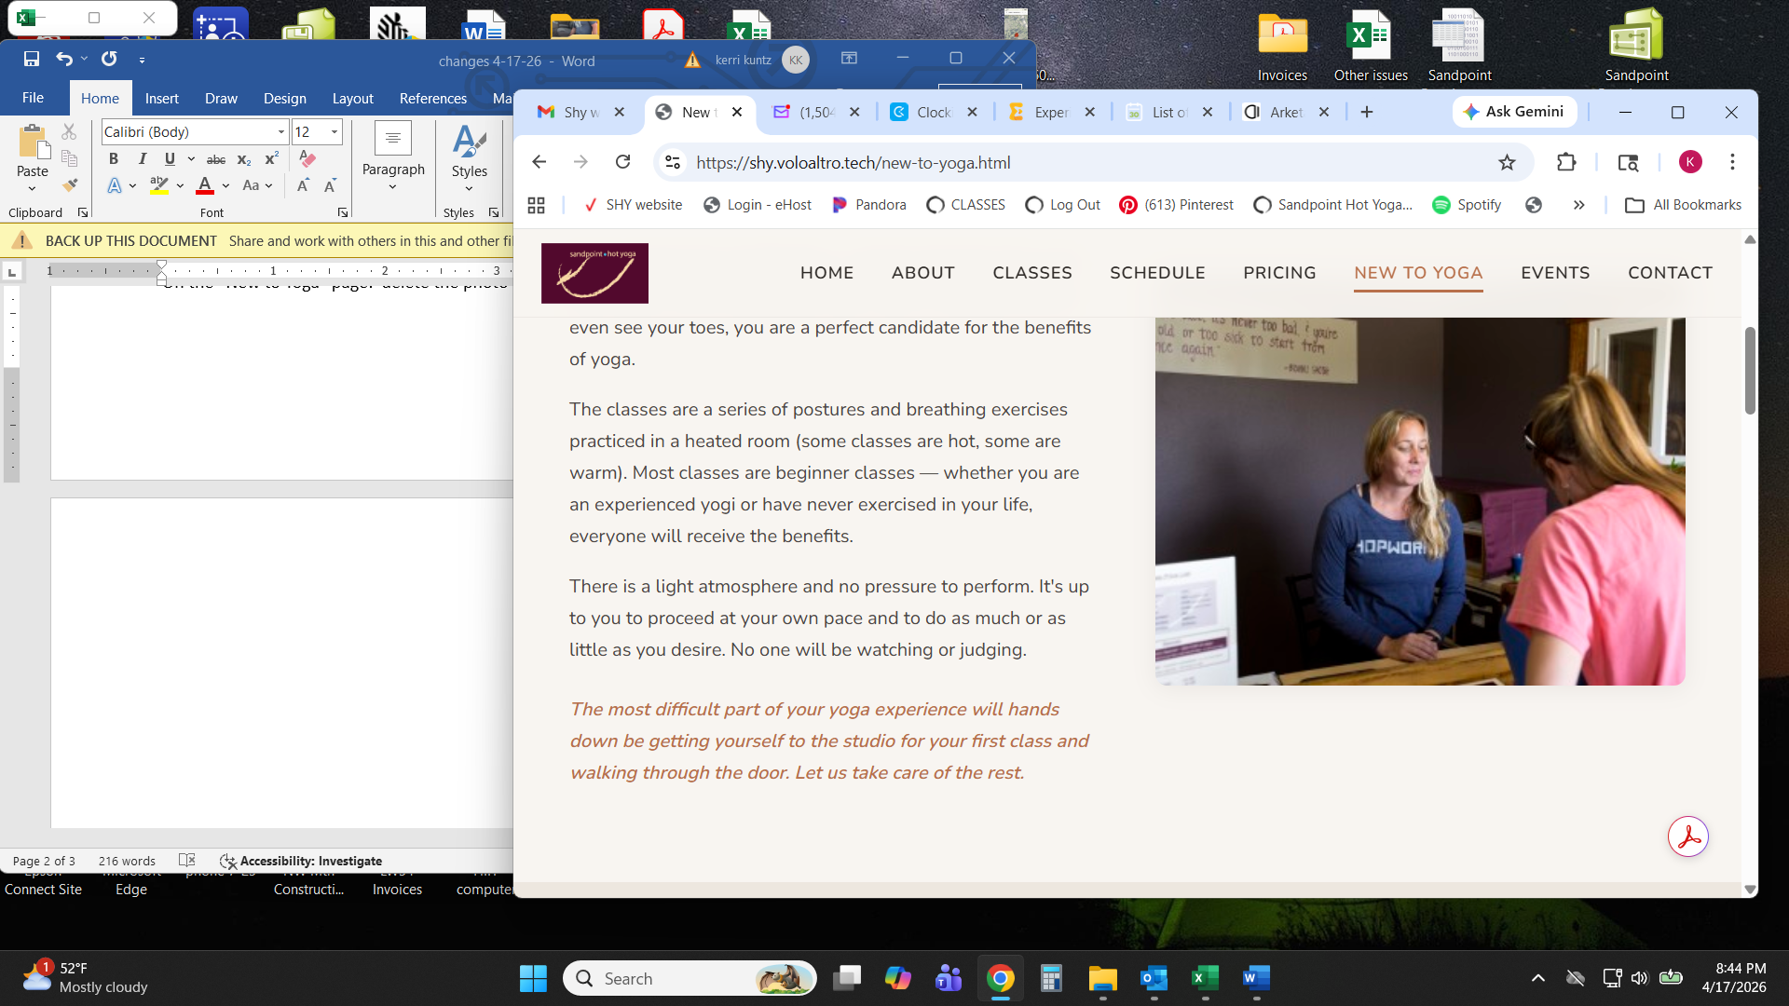

New to Yoga page: Common myths should be clickable to a page with a description like the old site
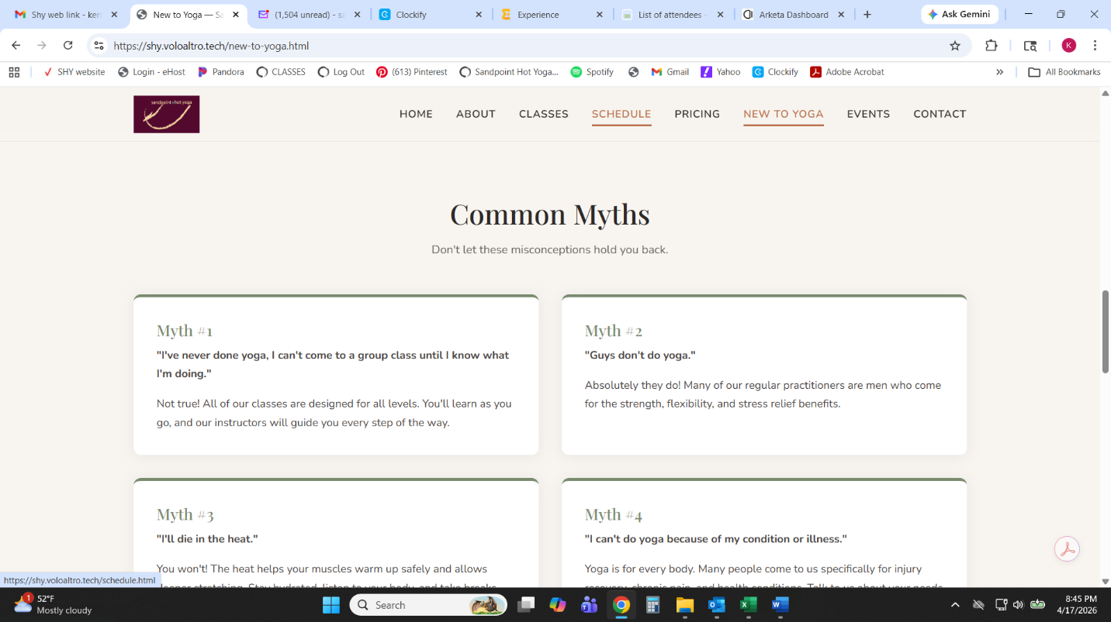

Add the tagline “This is Your Tribe” at the bottom of every page in a bright color with fun font

